Name

Mathematics Stage 5 Paths
Negative Index Laws

Book 1 |  | Version: 261007  Feedback:  https://MrDingMaths.com
Contents
Syllabus Content 2
Learning Intention 3

Syllabus Content
MA5-IND-P-01 applies the index laws to operate with algebraic expressions involving negative-integer indices
Apply index laws to algebraic expressions involving negative-integer indices
- Apply index notation, patterns and index laws to establish $a^{-1}=\frac{1}{a}$, $a^{-2}=\frac{1}{a^{2}}$, $a^{-3}=\frac{1}{a^{3}}$ and $a^{-n}=\frac{1}{a^{n}}$
- Represent expressions involving negative-integer indices as expressions involving positive-integer indices and vice versa
- Apply the index laws to simplify algebraic products and quotients involving negative-integer indices
- Describe and use $x^{-1}$ as the reciprocal of $x$ and generalise this relationship to expressions of the form ${\left(\frac{a}{b}\right)}^{-1}$
- Use knowledge of the reciprocal to simplify expressions of the form ${\left(\frac{a}{b}\right)}^{-n}$

Negative Index with Variables

- Index Law of Negative Powers
The negative index means to take the reciprocal of the base.
$$a^{-n}=\frac{1}{a^{n}}$$ | $$ba^{-n}=\frac{b}{a^{n}}$$
For negative powers in the numerator:
- Move the base to the denominator.
- Power becomes positive.

- Rewrite expressions involving negative indices with positive indices
$$x^{-2}$$  $$\frac{1}{x^{2}}$$ | $$3x^{-2}$$  $$\frac{3}{x^{2}}$$ |  | $$\frac{x^{-2}}{3}$$  $$\frac{1}{3x^{2}}$$ |  | $$12yx^{-7}$$  $$\frac{12y}{x^{7}}$$
Express the following with positive indices
- $x^{-3}$ |  | - $x^{-1}$ |  | - $a^{-4}$
- $3m^{-5}$ |  | - $p^{7}q^{-2}$ |  | - $x^{-4}y^{-3}$

- Key Ideas
- A negative index means to take the ……………………… of the base.
- If a base has a negative index, to make the index positive move it to the …………………

Foundation
- Express each of the following with positive indices and no brackets.
- $x^{-1}$  $$\frac{1}{x}$$ | - $a^{-4}$  $$\frac{1}{a^{4}}$$ | - $b^{-6}$  $$\frac{1}{b^{6}}$$
- $x^{-2}$  $$\frac{1}{x^{2}}$$ | - $2x^{-2}$  $$\frac{2}{x^{2}}$$ | - ${\left(2x\right)}^{-2}$  $$\frac{1}{4x^{2}}$$
- $3m^{-4}$  $$\frac{3}{m^{4}}$$ | - ${\left(3m\right)}^{-4}$  $$\frac{1}{81m^{4}}$$ | - $mn^{-4}$  $$\frac{m}{n^{4}}$$
- $p^{7}q^{-2}$  $$\frac{p^{7}}{q^{2}}$$ | - ${\left(pq\right)}^{-2}$  $$\frac{1}{p^{2}q^{2}}$$ | - $x{\left(yz\right)}^{-3}$  $$\frac{x}{y^{3}z^{3}}$$
- $x^{4}y^{-4}$  $$\frac{x^{4}}{y^{4}}$$ | - $2a^{-3}b^{-1}$  $$\frac{2}{a^{3}b}$$ | - $7r^{-2}s^{3}$  $$\frac{7s^{3}}{r^{2}}$$

- Simplify these expressions.
- $y^{13}×y^{4}$  $$y^{17}$$ | - $2x^{7}×5x^{4}$  $$10x^{11}$$
- $6y^{13}×5y^{4}$  $$30y^{17}$$ | - $12y^{5}×5x^{4}$  $$60x^{4}y^{5}$$
- $y^{13}÷y^{4}$  $$y^{9}$$ | - $12y^{5}÷6y^{4}$  $$2y$$
- $40y^{13}÷8y^{4}$  $$5y^{9}$$ | - $12y^{5}÷12y^{-4}$  $$y^{9}$$
- ${\left(y^{13}\right)}^{4}$  $$y^{52}$$ | - ${\left(12y^{5}\right)}^{2}$  $$144y^{10}$$
- ${\left(3y^{13}\right)}^{4}$  $$81y^{52}$$ | - ${\left(12y^{-3}\right)}^{2}$  $$\frac{144}{y^{6}}$$
- $7y^{4}÷y^{2}$  $$7y^{2}$$ | - $12y^{-3}÷4y^{2}$  $$\frac{3}{y^{5}}$$
- $7y^{4}×y^{2}$  $$7y^{6}$$ | - $12y^{-3}÷4y^{-2}$  $$\frac{3}{y}$$
- ${\left(7y^{4}\right)}^{2}$  $$49y^{8}$$ | - $12y^{-3}×4y^{-2}$  $$\frac{48}{y^{5}}$$

- Write these expressions without negative indices.
- $2^{-1}$  $$\frac{1}{2}$$ | - ${\left(-x\right)}^{-3}$  $$-\frac{1}{x^{3}}$$
- $3^{-1}$  $$\frac{1}{3}$$ | - $7x^{-3}$  $$\frac{7}{x^{3}}$$
- $3^{-2}$  $$\frac{1}{9}$$ | - ${\left(7x\right)}^{-3}$  $$\frac{1}{343x^{3}}$$
- $3^{-3}$  $$\frac{1}{27}$$ | - ${\left(7xy\right)}^{-3}$  $$\frac{1}{343x^{3}y^{3}}$$
- ${10}^{-3}$  $$\frac{1}{1000}$$ | - $-{\left(7xy\right)}^{-3}$  $$-\frac{1}{343x^{3}y^{3}}$$
- $x^{-3}$  $$\frac{1}{x^{3}}$$ | - ${\left(-7xy\right)}^{-3}$  $$-\frac{1}{343x^{3}y^{3}}$$
- $-x^{-3}$  $$-\frac{1}{x^{3}}$$ | - ${\left(-7xy\right)}^{-4}$  $$\frac{1}{2401x^{4}y^{4}}$$
- $-x^{-4}$  $$-\frac{1}{x^{4}}$$ | - ${\left(-7x^{2}y\right)}^{-4}$  $$\frac{1}{2401x^{8}y^{4}}$$
- ${\left(-x\right)}^{-4}$  $$\frac{1}{x^{4}}$$ | - $-{\left(-7x^{2}y^{n}\right)}^{-4}$  $$\frac{-1}{2401x^{4}y^{4n}}$$

- Express the following using positive indices.
- $x^{-5}$  $$\frac{1}{x^{5}}$$ | - $a^{-4}$  $$\frac{1}{a^{4}}$$ | - $2a^{-4}$  $$\frac{2}{a^{4}}$$ | - ${\left(2a\right)}^{-4}$  $$\frac{1}{16a^{4}}$$
- $3y^{-7}$  $$\frac{3}{y^{7}}$$ | - $3a^{2}b^{-3}$  $$\frac{3a^{2}}{b^{3}}$$ | - $4m^{3}n^{-3}$  $$\frac{4m^{3}}{n^{3}}$$ | - $10x^{-2}y^{5}$  $$\frac{10y^{5}}{x^{2}}$$
- $3x^{-5}$  $$\frac{3}{x^{5}}$$ | - $\frac{x^{-5}}{3}$  $$\frac{1}{3x^{5}}$$ | - $\frac{2a^{-3}}{5}$  $$\frac{2}{5a^{3}}$$ | - $\frac{{\left(3a\right)}^{-1}}{b}$  $$\frac{1}{3ab}$$
- $3x^{-4}y^{-2}z^{3}$  $$\frac{3z^{3}}{x^{4}y^{2}}$$ | - $\frac{1}{3}p^{-2}q^{3}r$  $$\frac{q^{3}r}{3p^{2}}$$ | - $\frac{1}{5}d^{2}e^{-4}f^{5}$  $$\frac{d^{2}f^{5}}{5e^{4}}$$ | - $\frac{3}{8}u^{2}v^{-6}w^{7}$  $$\frac{3u^{2}w^{7}}{8v^{6}}$$

- Read these examples carefully and answer the questions.
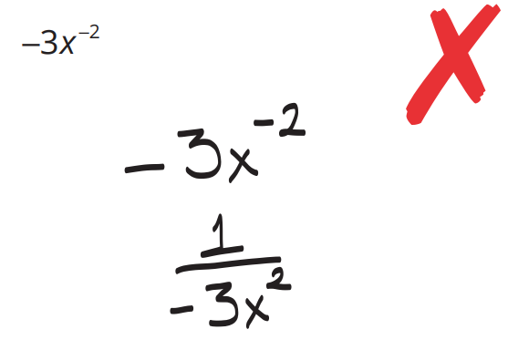  Kelly’s work | The –3 should have stayed in the numerator for Kelly’s final answer to be correct. Why does the –3 belong in the numerator?  Only the $x$ is being raised to the power of -2  Simplify:  $${-2x}^{-4}$$  $$-\frac{2}{x^{4}} or\frac{-2}{x^{4}}$$
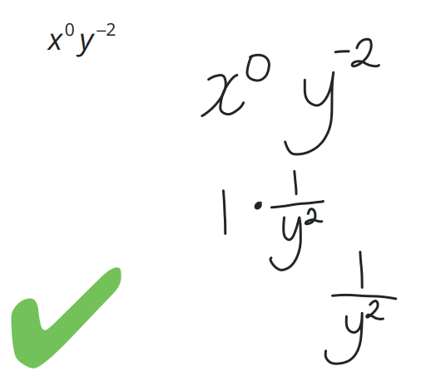  Danice’s work | Why was $x$ not included in Danice’s answer?  $x$ was raised to the power of 0, meaning it becomes 1.  Simplify:  $$a^{-4}b^{0}$$  $$\frac{1}{a^{4}}$$
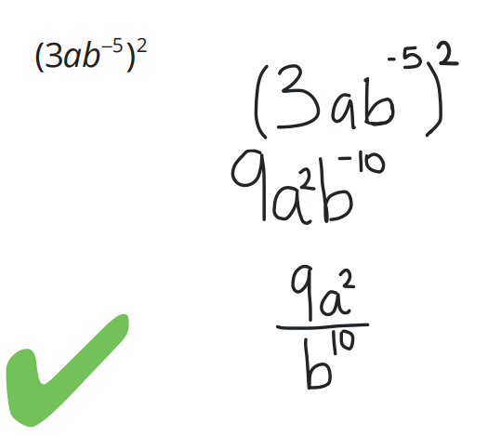  Maya’s work | Where did the 9 come from in Maya’s expression?  The 3 is inside brackets, so is raised to the power of 2.  The original expression did not contain a fraction. Why did Maya’s answer contain a fraction?  The negative power means take the reciprocal of b; it becomes $\frac{1}{b}$  Simplify:  $${\left(5a^{-3}b\right)}^{2}$$  $$\frac{25b^{2}}{a^{3}}$$

Negative Indices in the Denominator

- Index Law of Negative Powers
$$\frac{1}{a^{-n}}=a^{n}$$ | $$\frac{b}{a^{-n}}={ba}^{n}$$
For negative powers in the denominator:
- Move the base to the numerator.
- Power becomes positive.

- Rewrite expressions involving negative indices with positive indices
$$\frac{1}{x^{-2}}$$  $$x^{2}$$ | $$\frac{3}{x^{-2}}$$  $$3x^{2}$$ |  | $$\frac{1}{3x^{-2}}$$  $$\frac{x^{2}}{3}$$ |  | $$\frac{12}{yx^{-7}}$$  $$\frac{12x^{7}}{y}$$
Express the following with positive indices
- $\frac{1}{y^{-3}}$ |  | - $\frac{3}{y^{-2}}$ |  | - $\frac{1}{7x^{-8}}$
- $\frac{a^{2}}{b^{-3}}$ |  | - $\frac{7}{x^{-4}y^{3}}$ |  | - $\frac{3a}{y^{-5}}$

- Key Ideas
- A negative index means to take the ……………………… of the base.
- If a denominator has a negative index, to make the index positive move it to the …………………

Foundation
- Read the example carefully and answer the questions.
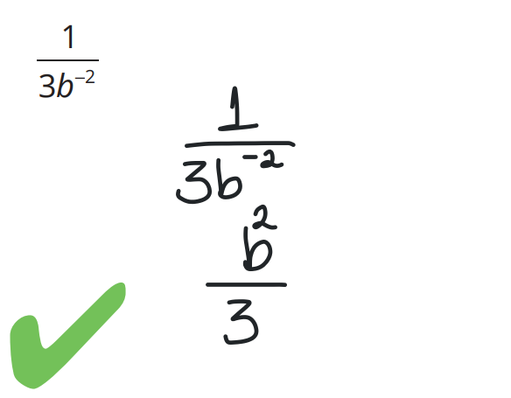  Andy’s work | Why did the negative sign disappear when Andy wrote his solution?  Negative powers in the denominator indicate to take the reciprocal of the base (move the base to the numerator) and make power positive.  Why did the 3 stay in the denominator?  The 3 was not raised to a negative power.  Simplify:  $$\frac{2}{x^{-3}}$$  $$2x^{3}$$

- Express each of the following with positive indices only.
- $\frac{1}{x^{-2}}$  $$x^{2}$$ | - $\frac{2}{y^{-3}}$  $$2y^{3}$$ | - $\frac{4}{m^{-7}}$  $$4m^{7}$$
- $\frac{4}{p^{-4}}$  $$4p^{4}$$ | - $\frac{a}{b^{-2}}$  $$ab^{2}$$ | - $\frac{e}{d^{-1}}$  $$ed$$
- $\frac{2b^{4}}{d^{-3}}$  $$2b^{4}d^{3}$$ | - $\frac{3m^{2}}{n^{-4}}$  $$3m^{2}n^{4}$$ | - $\frac{4b^{4}}{3a^{-3}}$  $$\frac{4b^{4}a^{3}}{3}$$
- $\frac{a^{-3}}{b^{-3}}$  $$\frac{b^{3}}{a^{3}}$$ | - $\frac{x^{-2}}{y^{-5}}$  $$\frac{y^{5}}{x^{2}}$$ | - $\frac{g^{-2}}{h^{-3}}$  $$\frac{h^{3}}{g^{2}}$$
- $\frac{5^{-1}}{7^{-3}}$  $$\frac{343}{5}$$ | - $\frac{3^{-2}}{4^{-3}}$  $$\frac{64}{9}$$ | - $\frac{5^{-2}}{6^{-1}}$  $$\frac{6}{25}$$
- $\frac{2n^{2}}{m^{-3}}$  $$2n^{2}m^{3}$$ | - $\frac{y^{5}}{{3x}^{-2}}$  $$\frac{x^{2}y^{5}}{3}$$ | - $\frac{-3}{{7y}^{-4}}$  $$-\frac{3y^{4}}{7}$$
- $\frac{-2}{b^{-8}}$  $$-2b^{8}$$ | - $\frac{-3g}{{4h}^{-3}}$  $$-\frac{3gh^{3}}{4}$$ | - $\frac{{\left(-3u\right)}^{2}}{5t^{-2}}$  $$\frac{9u^{2}t^{2}}{5}$$
- $\frac{7}{x^{-4}y^{3}}$  $$\frac{7x^{4}}{y^{3}}$$ | - $\frac{1}{u^{-3}v^{2}}$  $$\frac{u^{3}}{v^{2}}$$ | - $\frac{a^{-3}5^{-1}}{y^{-3}}$  $$\frac{y^{3}}{5a^{3}}$$
- $\frac{5a^{2}c^{-4}}{6b^{-2}d}$  $$\frac{5a^{2}b^{2}}{6c^{4}d}$$ | - $\frac{2a^{-4}}{b^{-5}c^{2}}$  $$\frac{2b^{5}}{a^{4}c^{2}}$$ | - $\frac{5^{-1}h^{3}k^{-2}}{4^{-1}m^{-2}p}$  $$\frac{4h^{3}m^{2}}{5k^{2}p}$$

Negative Index as the Reciprocal

- Index Law of Negative Powers
$${\left(\frac{a}{b}\right)}^{-1}=\frac{b}{a}$$ | $${\left(\frac{a}{b}\right)}^{-n}={\left(\frac{b}{a}\right)}^{n}=\frac{b^{n}}{a^{n}}$$
The negative index means to take the reciprocal of the base, i.e., invert the fraction.

- Example Simplify expressions using the reciprocal
$${\left(\frac{x}{y^{2}}\right)}^{-1}$$  $$=\frac{y^{2}}{x}$$ | $${\left(\frac{x}{y}\right)}^{-3}$$  $$={\left(\frac{y}{x}\right)}^{3}$$  $$=\frac{y^{3}}{x^{3}}$$

- Guided Practice
Express the following with positive indices.
- ${\left(\frac{5}{y}\right)}^{-1}$ | - ${\left(\frac{x}{3}\right)}^{-2}$ | - ${\left(\frac{x^{3}}{y}\right)}^{-2}$
- ${\left(\frac{3y}{x^{5}}\right)}^{-1}$ | - ${\left(\frac{2x^{5}}{y}\right)}^{-3}$ | - ${\left(\frac{1}{3}\right)}^{-2}$

- Key Ideas
- A negative index means to take the ……………………… of the base.
- Take the reciprocal by swapping the ……………… and …………………

Foundation
- Simplify these expressions by writing them without negative indices.
- ${\left(\frac{5}{4}\right)}^{-1}$  $$\frac{4}{5}$$ | - ${\left(\frac{2}{7}\right)}^{-1}$  $$\frac{7}{2}$$ | - ${\left(\frac{x}{3}\right)}^{-1}$  $$\frac{3}{x}$$ | - ${\left(\frac{a}{b}\right)}^{-1}$  $$\frac{b}{a}$$
- ${\left(\frac{3}{4}\right)}^{-1}$  $$\frac{4}{3}$$ | - ${\left(\frac{x}{y}\right)}^{-1}$  $$\frac{y}{x}$$ | - ${\left(\frac{bx}{y}\right)}^{-1}$  $$\frac{y}{bx}$$ | - ${\left(\frac{2x^{2}}{3y}\right)}^{-1}$  $$\frac{3y}{2x^{2}}$$
- ${\left(\frac{2}{3}\right)}^{-2}$  $$\frac{9}{4}$$ | - ${\left(\frac{3}{2}\right)}^{-2}$  $$\frac{4}{9}$$ | - ${\left(\frac{1}{2}\right)}^{-5}$  $$32$$ | - ${\left(\frac{2}{5}\right)}^{-3}$  $$\frac{125}{8}$$
- ${\left(\frac{xy}{2}\right)}^{-4}$  $$\frac{16}{x^{4}y^{4}}$$ | - ${\left(\frac{x}{5}\right)}^{-2}$  $$\frac{25}{x^{2}}$$ | - ${\left(\frac{5x}{ab}\right)}^{-3}$  $$\frac{a^{3}b^{3}}{125x^{3}}$$ | - ${\left(\frac{7}{3y}\right)}^{-3}$  $$\frac{27y^{3}}{343}$$
- ${\left(\frac{x^{3}}{ab}\right)}^{-5}$  $$\frac{a^{5}b^{5}}{x^{15}}$$ | - ${\left(\frac{xy}{3n^{4}}\right)}^{-2}$  $$\frac{9n^{8}}{x^{2}y^{2}}$$ | - ${\left(\frac{2x^{4}}{ab^{2}}\right)}^{-5}$  $$\frac{a^{5}b^{10}}{32x^{20}}$$ | - ${\left(\frac{7a^{2}}{9x^{7}}\right)}^{-1}$  $$\frac{9x^{7}}{7a^{2}}$$

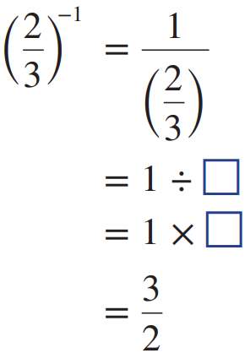
- Consider ${\left(\frac{2}{3}\right)}^{-1}$
Complete this working out.

$$1÷\frac{2}{3}$$
$$1×\frac{3}{2}$$

Mixed Practice

- Index Laws of Negative Powers
$$a^{-n}=\frac{1}{a^{n}}$$ | $$\frac{1}{a^{-n}}=a^{n}$$ | $${\left(\frac{a}{b}\right)}^{-n}=\frac{b^{n}}{a^{n}}$$

Foundation
- Write these expressions using positive indices.
- $a^{-3}$  $$\frac{1}{a^{3}}$$ | - $\frac{1}{a^{-3}}$  $$a^{3}$$ | - $2a^{-3}$  $$\frac{2}{a^{3}}$$ | - $\frac{2}{a^{-3}}$  $$2a^{3}$$
- $\frac{a^{-3}}{2}$  $$\frac{1}{2a^{3}}$$ | - $\frac{5a^{-3}}{2}$  $$\frac{5}{2a^{3}}$$ | - $\frac{5}{2a^{-3}}$  $$\frac{5a^{3}}{2}$$ | - $\frac{4a^{-3}}{7b^{-5}}$  $$\frac{4b^{5}}{7a^{3}}$$

- Simplify these expressions. Write your final answer using positive indices.
- $x^{2}y×x^{4}y^{3}$  $$x^{6}y^{4}$$ | - $x^{-5}y^{3}×x^{3}y^{-2}$  $$\frac{y}{x^{2}}$$ | - $0.2s^{-2}t^{3}×5st^{-5}$  $$\frac{1}{st^{2}}$$
- $56x^{2}y^{6}÷8xy^{8}$  $$\frac{7x}{y^{2}}$$ | - ${\left(s^{2}y^{-3}\right)}^{3}$  $$\frac{s^{6}}{y^{9}}$$ | - ${\left(5c^{-2}d^{3}\right)}^{-1}$  $$\frac{c^{2}}{5d^{3}}$$
- $3a^{-4}×2a^{2}$  $$\frac{6}{a^{2}}$$ | - $5m^{-4}×(-2m^{-2})$  $$-\frac{10}{m^{6}}$$ | - $\frac{2x^{-2}}{3x^{-3}}$  $$\frac{2x}{3}$$
- $\frac{7d^{-3}}{10d^{-5}}$  $$\frac{7d^{2}}{10}$$ | - $\frac{6c^{-5}}{12c^{-5}}$  $$\frac{1}{2}$$ | - $\frac{5s^{-2}}{3s}$  $$\frac{5}{3s^{3}}$$
- $\frac{4f^{-5}}{3f^{-3}}$  $$\frac{4}{3f^{2}}$$ | - $\frac{3d^{-3}}{6d^{-1}}$  $$\frac{1}{2d^{2}}$$ | - $\frac{15t^{-4}}{18t^{-2}}$  $$\frac{5}{6t^{2}}$$
- ${\left(2a^{-2}y^{3}\right)}^{-2}×{\left(2ay^{-3}\right)}^{3}$  $$\frac{2a^{7}}{y^{15}}$$ | - ${\left(5st^{2}\right)}^{3}÷{\left(5s^{-1}t^{3}\right)}^{2}$  $$5s^{5}$$ | - ${\left(2a^{-2}y^{3}\right)}^{-2}÷{\left(2ay^{-3}\right)}^{3}$  $$\frac{ay^{3}}{32}$$

Development
- Write these expressions with negative indices.
- $\frac{1}{x}$  $$x^{-1}$$ | - $\frac{9}{x^{2}}$  $$9x^{-2}$$ | - $\frac{1}{6x^{2}}$  $$\frac{x^{-2}}{6}$$
- $-\frac{1}{x}$  $$-x^{-1}$$ | - $\frac{9}{x^{3}}$  $$9x^{-3}$$ | - $-\frac{1}{6x^{2}}$  $$-\frac{x^{-2}}{6}$$
- $-\frac{12}{x}$  $$-12x^{-1}$$ | - $\frac{9}{x^{5}}$  $$9x^{-5}$$ | - $-\frac{5}{6x^{2}}$  $$-\frac{5x^{-2}}{6}$$
- $-\frac{12}{x^{2}}$  $$-12x^{-2}$$ | - $\frac{1}{6x}$  $$\frac{x^{-1}}{6}$$ | - $-\frac{5}{10x^{2}}$  $$-\frac{x^{-2}}{2}$$

- Simplify these expressions. Write using positive indices.
- $x^{-2}×x^{-3}$  $$\frac{1}{x^{5}}$$ | - $k^{5}÷k^{-6}$  $$k^{11}$$ | - ${\left(y^{-3}\right)}^{2}$  $$\frac{1}{y^{6}}$$
- $a^{5}÷a^{7}×a^{-4}$  $$\frac{1}{a^{6}}$$ | - $xy^{3}×x^{2}y^{-2}$  $$x^{3}y$$ | - $\frac{h^{10}×{\left(h^{-3}\right)}^{5}}{h^{2}}$  $$\frac{1}{h^{7}}$$
- $5y^{-2}×4xy^{6}÷2xy^{-3}$  $$10y^{7}$$ | - ${\left(6x^{-4}\right)}^{2}÷4x^{-3}$  $$\frac{9}{x^{5}}$$ | - ${\left(\frac{2x^{2}}{x^{3}}\right)}^{4}$  $$\frac{16}{x^{4}}$$
- ${\left(\frac{m^{3}}{4m^{5}}\right)}^{3}$  $$\frac{1}{64m^{6}}$$ | - $2{\left(x^{-7}\right)}^{3}$  $$\frac{2}{x^{21}}$$ | - $4{\left(d^{-2}\right)}^{3}$  $$\frac{4}{d^{6}}$$
- ${\left(3t^{-4}\right)}^{2}$  $$\frac{9}{t^{8}}$$ | - $5{\left(x^{2}\right)}^{-2}$  $$\frac{5}{x^{4}}$$ | - $7{\left(h^{-2}\right)}^{-4}$  $$7h^{8}$$
- $-8{\left(x^{5}\right)}^{-3}$  $$-\frac{8}{x^{15}}$$ | - ${\left(\frac{4}{y^{2}}\right)}^{-2}$  $$\frac{y^{4}}{16}$$ | - ${\left(\frac{3}{h^{3}}\right)}^{-4}$  $$\frac{h^{12}}{81}$$

- HSC Advanced Sample Question
Simplify ${\left(\frac{p}{q}\right)}^{3}÷\left(pq^{-2}\right)$

$$\frac{p^{2}}{q}$$
- NAPLAN B+
Simplify $\frac{36t^{4}}{9t^{-2}}$

$$4t^{6}$$
- NAPLAN A
Simplify $\frac{24p^{-3}q^{4}}{8pq^{2}}$ and express as a fraction involving non-negative indices only.

$$\frac{3q^{2}}{p^{4}}$$
- NAPLAN A
Simplify ${\left(\frac{3y^{3}}{2}\right)}^{-2}$ and express as a fraction involving non-negative indices only.

$$\frac{4}{9y^{6}}$$
- NAPLAN A
Simplify ${\left(\frac{4p^{2}}{8}\right)}^{-3}$ and express as a fraction involving non-negative indices only.

$$\frac{8}{p^{6}}$$
- If $x^{4}=3$, find the value of:
- $x^{4}-1$  $$2$$ | - $x^{8}$  $$9$$ | - $2x^{16}$  $$162$$ | - $3x^{4}-3x^{8}$  $$-18$$

Mastery
- Simplify.
- ${\left(a^{3}b^{2}\right)}^{3}×{\left(a^{2}b^{4}\right)}^{-1}$  $$a^{7}b^{2}$$ | - $\frac{2a^{3}b^{2}}{a^{-3}}×\frac{2a^{2}b^{5}}{b^{4}}$  $$4a^{8}b^{3}$$ | - $\frac{{\left(3rs^{2}\right)}^{4}}{r^{-3}s^{4}}×\frac{{\left(2r^{2}s\right)}^{2}}{s^{7}}$  $$\frac{324r^{11}}{s}$$
- $\frac{4{\left(x^{-2}y^{4}\right)}^{2}}{x^{2}y^{-3}}×\frac{xy^{4}}{2x^{-2}y}$  $$\frac{2y^{14}}{x^{3}}$$ | - ${\left(\frac{a^{2}b^{3}}{b^{-2}}\right)}^{2}÷{\left(\frac{ab^{4}}{a^{2}}\right)}^{-2}$  $$a^{2}b^{18}$$ | - ${\left(\frac{m^{4}n^{-2}}{r^{3}}\right)}^{2}÷{\left(\frac{m^{-3}n^{2}}{r^{3}}\right)}^{2}$  $$\frac{m^{14}}{n^{8}}$$

- Simplify, expressing the answers with positive indices. Evaluate powers where possible.
- ${\left(3a^{2}b^{-2}\right)}^{3}×{\left(2a^{4}\right)}^{-2}$  $$\frac{27}{4a^{2}b^{6}}$$ | - ${\left(5x^{4}y^{6}\right)}^{-3}×{\left(5^{2}xy^{-1}\right)}^{3}$  $$\frac{1}{x^{9}y^{21}}$$ | - ${\left(5m^{2}n^{-3}\right)}^{-2}×2{\left(m^{-2}n^{3}\right)}^{2}$  $$\frac{2n^{12}}{25m^{8}}$$
- $\frac{{\left(2a^{4}b^{-2}\right)}^{3}}{c^{2}}×\frac{{\left(2^{2}a^{-3}b^{2}\right)}^{-1}}{c}$  $$\frac{2a^{15}}{c^{3}b^{8}}$$ | - $\frac{{\left(m^{2}n^{3}\right)}^{2}}{p^{-3}}$ $×{\left(mnp^{-2}\right)}^{-3}$  $$mn^{3}p^{9}$$ | - $\frac{{\left(a^{2}\right)}^{3}}{b^{3}}÷{\left(\frac{a}{b^{2}}\right)}^{-2}$  $$\frac{a^{8}}{b^{7}}$$
- $\frac{{\left(2a^{4}\right)}^{2}}{b^{7}}÷\frac{{\left(a^{2}\right)}^{-3}}{2b}$  $$\frac{8a^{14}}{b^{6}}$$ | - $\frac{{\left(4c^{4}d^{-3}\right)}^{2}}{9}÷\frac{3c^{-2}}{d}$  $$\frac{16c^{10}}{27d^{5}}$$ | - $\frac{{\left(3m^{2}n^{3}\right)}^{-2}}{p^{4}}÷\frac{p^{-3}}{m}$  $$\frac{1}{9m^{3}n^{6}p}$$

